Using Metacognitive Practices to
Improve Efficacy of Peer Review

Participants in this workshop will be able to:
- Explain the metacognitive strategies Think Aloud and Talking to the Text
- Use these metacognitive strategies in their own classes
- Explain the benefits of using these metacognitive strategies in the writing classroom

What is metacognition?
_________________________________________________________________________________________________________
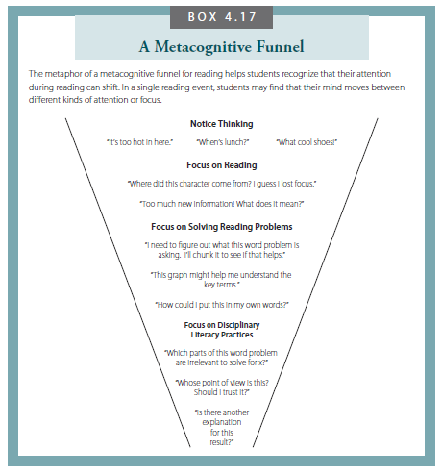
p. 128 – Reading for Understanding, 2nd edition
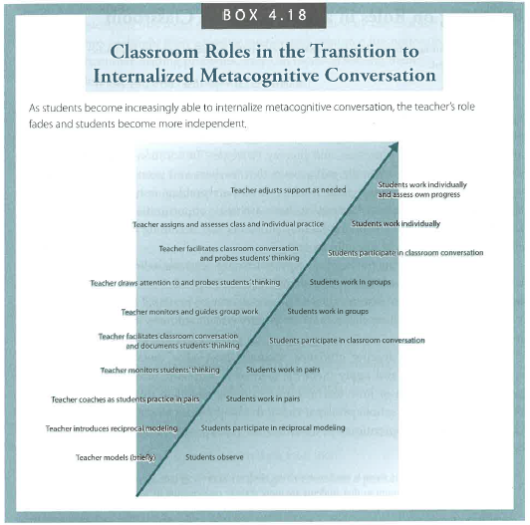
p. 132 – Reading for Understanding, 2nd edition
Talking to the Text:
Student is entering into a dialogue with the text on paper, writing questions in the margins related to specific pieces of the text

Think Aloud:
Student engages in a conversation with the text orally, commenting or questioning as they read out loud. Partners listen and record.

Combining Strategies:
- Students first read the essay themselves and Talk to the Text
- They next complete a worksheet to make sure the important pieces of the essay are present.
- Then, they read the essay to their partner (the writer) as a supported Think Aloud
This method is scaffolded and supported for non-native English Speakers, but these strategies can be altered and combined in different strategies for different student populations.

