Just Do It! Making the Shift to a Reading Apprenticeship Classroom

Personal
Dimension
Knowledge- Building Dimension

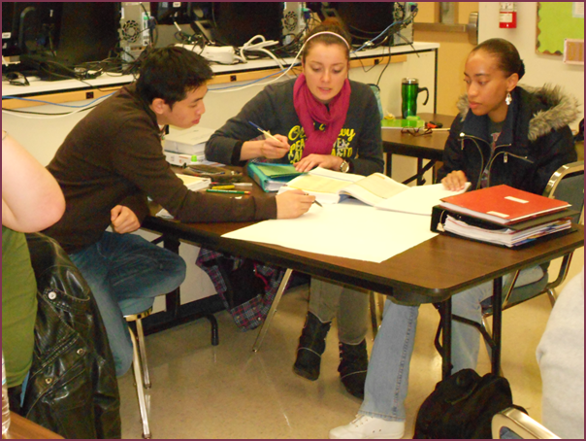
Social
Dimension
Cognitive
Dimension
Presented by Michele Lesmeister
mlesmeister@RTC.edu
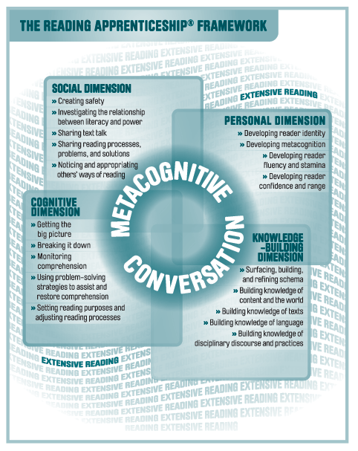

Think – Pair – Share
This routine helps to differentiate instruction by providing the students with some time and structure for thinking about their texts. This helps build community in a classroom when it is embedded a classroom norm. This routine gives students a voice in making meaning and a voice in deconstructing text and reconstructing meaning. Think Pair Share is an active learning routine which uses the personal and social dimension and supports the cognitive and knowledge-building dimensions.
The Think- Pair- Share Protocol
Think: Students first think individually about a prompt.
Ask them to review their class notes, Evidence Logs, Metacognitive Logs, or Talking to the Text mark ups.
Pair: Students share his or her individual thinking with a partner.
Ask one student to share his/her thinking while the partner listens quietly. Give guidance about how long each person has and this time should be short (1-2 minutes) then the partners switch and the other person shares while the person who initially spoke just listens. It helps if your pairs have adequate room to sit next to the partner and hear what is being said. The faculty should circulate and monitor the paired sharing and only facilitate in the process of the routine rather than interject about the sharing’s content.
Share: Pairs then share out at their tables for a short time and then finally there is whole class sharing.
Faculty should track the ideas on a poster or the white board. Model noting which ideas are given more than once. Focus on evidence from the text, similarities, differences, and common threads.

Remember that some students need to practice this routine to be able to engage in it. Perhaps listing the students and time allotments will help students learn how to engage in meaningful think pair share work.

Think – Pair – Share

Text Features

Text Features found in the Text | How do these text features help me make meaning?

Name ____________________________________________ 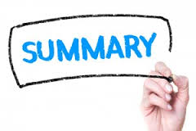
Write a 25-word summary of the reading passage assigned. This summary should capture the main idea or point of the section of the text you are reading. Use your sentence structure knowledge to keep the summary to 25 words or less.
____________________________________________________________________________________________________________________________________________________________________________________________________________________________________________________________________________________________________________________________________________________

Name ____________________________________________
Write a 25-word summary of the reading passage assigned. This summary should capture the main idea or point of the section of the text you are reading. Use your sentence structure knowledge to keep the summary to 25 words or less.
____________________________________________________________________________________________________________________________________________________________________________________________________________________________________________________________________________________________________________________________________________________

Teacher Resources
Possible Reading Apprenticeship Outcomes to include in your syllabi
Outcomes | Some Ways of Measuring
Articulate personal supports and barriers to literacy development | Personal Reading History  Ongoing Formative Assessment  Curriculum Embedded Reading Assessment (CERA) Rubric Evaluation  MARSI
Demonstrate individualized reading/thinking process | Think Aloud  Talking to the Text
Participate in a community of readers | Readers Strategy List Compilation  Gallery Walks  Discussion Board Participation  Give One/Get One  Whole Class: one-line abstract
Identify problem areas and track the process for clarification. | Talking to the Text
Engage in the metacognitive conversation to increase comprehension of material | Talking to the Text  CERA Rubric Evaluation
Activate schema and use it to increase comprehension of text | Frayer Model  Think Aloud  KWL  Anticipation Guides  E/I Preview Charting

Community Norms
Building Community Norms: Essential Activity
I love doing the classroom norms each quarter because it gives the students their first voice and say in how the class is going to run. They are valued contributors to the community of practice that we have created in each class. I use this activity to set the tone of my interest in their ideas and to celebrate their presence in the classroom.
Identity and Community  Learning is socially mediated. Feeling part of a classroom community has significant psychological benefits and makes students more likely to engage in productive academic behaviors. | Classroom norms and routines create a sense of safety and belonging  - Negotiated classroom norms support all students to share ideas and comprehension difficulties without feeling stupid or “uncool.”  - Teachers tap students’ out-of-school interests and competencies to help students recalibrate their academic potential and identities.  - Small group work and collaborative meaning-making routines engage all students in thinking, discussing, and actively participating in the academic life of the classroom.
Source: http://readingapprenticeship.org/our-approach/common-core/social-emotional/
Set Up:
- Have the students individually think about
"Think about times—in as well as out of school --when you learned something new. Make some notes about what helped you feel comfortable about learning in that situation. Focus on what made the learning happen rather than the content you learned."
- Pair and share
- Report out and create a living classroom document (It is important to use the language of the students for this document.)
Personal Reading History:
A personal reading history can help students think about and write about their literacy development and the key events in their development as a reader. When students can reflect on and analyze their past reading experiences, it is easier to develop better reading skills in the future.
In order to receive a high quality response, the personal reading histories should be assigned as individual work first. Then they can pair with a partner and share their experiences making sure that each person has a few minutes to share his or her history. Once the pairs are done, then the class can share widely their findings and the common threads can be recorded on the board.
This sends the message: reading is important, reading is complex, and each student has a reader identity. Your message to the student is that you are creating a community of readers by fostering an understanding about how we read, the processes of reading different texts in different ways, and drawing on the shared processes of reading present in the classroom.
This activity should be done during the first week of class and can potentially be assigned as homework for one night with the pair and share and group discussion following the next day.
As an instructor, I read each student’s personal reading history; I gain insight into how the student sees himself or herself as a reader, learning differences, and personal attributes that can help guide my classroom.

Personal Reading History

Please answer the following questions about your literary development:
- What are some high points in your learning to read literature?

- What are some low points in your learning to read literature?

- Were there times when you felt like an “insider” or times when you felt like an “outsider”?

- What or who supported your literacy development? What or who discouraged it?

Pair and Share: Share some of your reading history with a partner. Make sure that each of you has an opportunity to tell your story.
Whole class sharing: What did you learn about each other? What are the common threads? What were the surprises?

Personal Reading History
Circle the pictures that answer the questions for you.
Reading in English is _______________.
Good hard easy and fun impossible

Who helps you read in English?
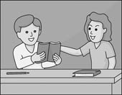
Teacher family Coworkers Friends or classmates

What do you like to read?

Books Newspaper Magazine Online

Reading Strategy List:
What is a Reader’s Strategy List (RSL)?
A reader’s strategy list is a student-generated list of approaches they use to figure out text. This is a living community document.
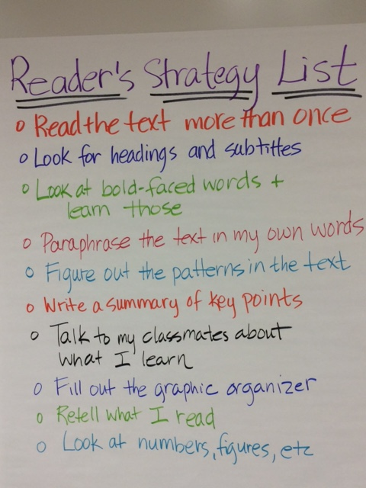
One easy way to get the conversation going in your classroom is to ask your readers how they read. Given an opportunity to reflect and think about how they approach a text is insightful, and students will reveal some of their approaches to reading. This opportunity to share in discussing reading processes helps others think about their own approaches to reading.
Reading Apprenticeship methods suggest that students first individually document their own methods or strategies for reading a specific text. Remember that there are many ways of approaching text. Next the students should pair up and share what they have written. Once that conversation has taken place, the class should report out their findings. In this way, readers have an opportunity to report on their own habits, listen to the reading habits of others, and then create a shared document, which is hung in the classroom as a living document.
The Reader’s Strategy List is generated by students for students. It is an ongoing dynamic classroom artifact. It serves as a reminder to students that there are different ways of reading, that different texts require different methods, and that the process of reading discipline-specific texts is essential to understand if one hopes to improve his effectiveness and mastery of complex academic texts.
How is it created?
•We query students about how they made sense of a text and then create a living classroom document for their use.
•This is a student-generated list. The language on the list is the students' terminology.
•You may have multiple lists: one for math problems, one for a manual, one for a primary text.

Why are the Readers Strategy Lists helpful for students?
These give students a way to voice how they approach text. It allows for sharing across the four dimensions. Students often uncover how they are reading text, and this gives the instructor insight into how they read the disciplinary texts. You can model strategies of how to read the text that they may not have considered.

My Reader’s Strategy List

My Reader’s Strategy List

Category: _______________________________________________

Strategy | How it helps

My Reading Strategy List

Reading and talking together Read Again Read Out Loud

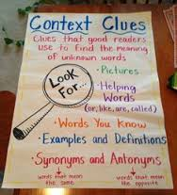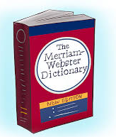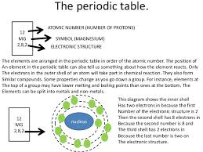
Use context clues Use a dictionary Look for patterns
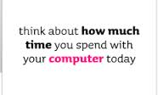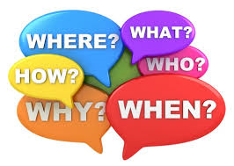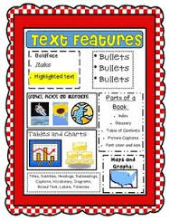
Look for bold words Ask Questions Use Text Features
Schema: Your prior knowledge of the world
Our students bring all sorts of knowledge the classroom and as such they can become contributors to meaning making in our classroom, if we encourage and promote their schema. To help us summarize some of the schema that students bring to the classroom, we can categorize this knowledge:
- Knowledge about the text’s content and the world
- Knowledge about different types of texts
- Knowledge about language: words, syntax, mechanics, and semantics
- Knowledge about disciplinary discourse and practices
- Knowledge about culture and how culture is present in language, thinking, and text.
I tell the students in my class that text is ink on paper until they bring themselves to their texts. The idea is to promote the growth of schema in the classroom because the more knowledge one has on a topic, the easier it is to read in the subject area and the more one can learn.
Our goals as facilitators should be to help students become metacognitive about schema. We can do this by helping them learn how to activate their schema. We need to give the students opportunities to search for discernible patterns and schema connections. By helping the students become metacognitive about their schema, prior knowledge, we help me become active learners and thinkers and it is through this work that we are able to help students exchange and revise schema that is misleading or incorrect.
How can we promote students being metacognitive about schema and schema building?
- Have students create inquiry questions prior to reading the text, introduce word games like Hinky Pinkies, Word Puzzles, and ambiguous Headlines and Cartoons
- Promote collaboration through the social dimension
- Make confusions cool
- As the instructor, show patience as students debate and struggle with making meaning.

Brainstorming of Words or Concepts
Topic: | A | B | C
D | E | F | G
H | I | J | K
L | M | N | O
P | Q | R | S
T | U | V | W
X | Y | Z

Frayer Model
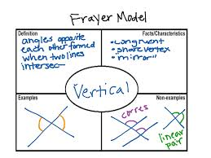
The Frayer Model is graphic organizer that was designed by Dorothy Frayer and her colleagues at the University of Wisconsin. Her organizer provides students with a way to understand new words. Students are asked to provide a definition of the term, facts or characteristics of the word, examples, and non-examples.
The model is one way to scaffold concepts from words and activate schema for preparing student to read text.
I use two formats:
My definition of the term  Term | Facts and/or Characteristics
Examples | Non-examples

My definition of the term  Term | Illustrate the concept
Examples | Non-examples

My Definition | Facts/Description/Illustration
Examples | Non-Examples
Frayer Model

Scaffolding: Why it matters in our classrooms
When we discuss scaffolding in our college classroom, we are talking about breaking up and supporting the learning. To do this we chunk the text and provide a tool or structure to support each chunk. Scaffolding supports all learners.
We have so many ways to scaffold conversations and scaffold texts we want to teach.
Scaffolding Academic Conversations | Scaffolding Academic Texts
- Be explicit in your instructions and protocols  - Make sure the protocols are visible (on board) as well as explained  - Ensure that the purpose of the activity is clear to all students  - Encourage participation  - Use time limits to set an urgency in the classroom  - Do something to activate schema  - Model effective listening  - Provide sentence frames to get the conversations moving  - Accept all contributions  - Move to the sidelines  - Allow for multi-modality in preparation(some will write, others will read, listen, or sketch)  - Assign an expert or subject matter sage | - Be explicit in your instructions and protocols  - Make sure the protocols are visible (on board) as well as explained  - Ensure that the purpose of the activity is clear to all students  - Use a Frayer Model to activate schema  - Pre-teach vital vocabulary  - Showcase vocabulary in context with sentence structure, punctuation, word clues, etc.  - Activate schema by using visual aids and media to activate schema  - Chunk the text into manageable units and assign to pairs or groups  To complete an evidence log poster of what the main points are and evidence supporting the evidence  - Ask students to connect concepts  - Use graphic organizers  - Model with Think Alouds and Talking to the Text routines

I try to remember that I am “apprenticing” my students, so I need to be intentional and explicit in my efforts to scaffold and support my readers as they de-construct a text and then re-construct this text to make meaning.

Think Aloud:
What is a Think Aloud?
All Reading Apprenticeship teachers use the Think Aloud routine to model the ways that readers think about their texts. A Think Aloud is the reading of a short chunk of text coupled with the thinking that runs through your mind as you read the text. The text and the thinking are both verbalized. When teachers show their mental activity while reading, students are on boarded about what they should also be doing when they read.
Why Use Think Alouds?
By using Think Alouds in your class, you help the students “see” your thinking processes as you read. As you read the passage, in a Think Aloud you explain how you make sense of text that may be confusing for students (new vocabulary, unusual sentence construction, complex terms and field specific uses, ideas that help develop your understanding of the text). This strengthens the students’ ability to apply new thinking and processing skills to text. Do not worry about modeling too much. Think Alouds should be routine in your classroom.
Across campus, students have told us some new ideas they have gained from observing faculty engage in think aloud modeling:
- I can bring my own knowledge to the text.
- Rereading is not a sign that I am a slow reader, but it means that I am working to make meaning.
- Teachers sometimes do not see what I do not know, so asking for clarification as the teacher models helps me.
- Different strategies are used for different texts. I discovered that there are many ways of reading.
- Talking aloud helps me figure out meaning because I am hearing it and reading it at the same time.
- I see that punctuation is really important in English. If I understand differences between a semi-colon and a colon, this can help my comprehension of sentences.
- Reading is not a simple task.
Readers observe their faculty as expert readers. They monitor their understanding by rereading a sentence, reading ahead to clarify, and/or looking for context clues.

The following chart offers ways to model reading strategies in a Think Aloud.
Strategy of Think Aloud | Word to begin verbalize what is in the text
Predicting | I predict … In the next part I think … I think this is …
Questioning | Why did … What did … How did … Where was …Should  there …
Visualizing | I see … I imagine that… I picture …
Personal Response | I feel … My favorite part … I liked/disliked …
Clarifying | I got confused when … I’m not sure of …  I didn’t expect …
Summarizing | I think this is mainly about … Most important is
Reflecting | I think I’ll … next time. I wonder if…  Maybe I’ll need to … next time. I realize that…
Making Connections  - personal connections  - text-to-text connections | This is like … This reminds me of … This is similar to …

A Think Aloud is primarily verbal and metacognitive conversations should be the result. It takes students a while to figure out what constitutes a metacognitive conversation. Sometimes it is easier to tell the students it is not a content discussion, but a discussion that showcases their thinking about a text.
How do I do a Think Aloud?
Model a short section of the text by reading and thinking out loud. Be authentic in your modeling. Show what is happening inside your head as you read. Keep it short –2 to 3 minutes. After your model is complete, ask the students to comment on what they noticed about your Think Aloud.
Pair the students and ask them to do a Think Aloud switching partners by modeling their thinking short section by section. (Keep the sections short.) Provide a few minutes for them to share what they noticed about each other’s thinking. Finally, share out these discoveries to the whole class.
Metacognitive Logs:
Metacognitive logs have many purposes and benefits. These logs help students look for and pull evidence from their texts. These logs allow faculty to see how the students engage and generate inquiry about a text. The logs help students become aware of their thinking as readers; this empowers them to take control of how well they learn. Faculty first model this routine, and this routine will need to be scaffolded with some metacognitive prompts or starters.

While I was reading …
I felt confused about …
I was distracted by …
I started to think about …
I got stuck when …
The time went by so quickly because …
A word or some words I did not know …
I stopped because …
I lost track of everything except …
I figured out that …
I first thought that …but then realized that …
I finally understood …
I remember that earlier in the book …
This contributes to what I know by …
This is significant because it …

Metacognitive Log
Name ________________________________________ Date__________________________
Text ________________________________________ Chapter_______/Pages_____________
A. Respond to two of the metacognitive prompts below. Write a complete, thoughtful sentence or two for each prompt. Try a different prompt for each log.

- While I was reading…
- I felt confused when….
- I was distracted by….
- I started to think about….
- I got stuck when …
- The time went by quickly because …
- A word/some words I did not know…
- I stopped because…
- I lost track of everything except…
- I figured out that…
- I first thought that…but then realized that…
- I finally understood…
- I remembered that earlier in the book…
- This contributes to what I know by…

Write down two questions or observations that you could ask or make about this reading.
Evidence Logs
Like the metacognitive log, this graphic organizer asks the students to locate meaningful and significant sentences in a text, and then to make some connection to him/herself, the world, or another text.
Notice that there are no prompts to guide them. As always, the students need to note the page and paragraph number.
As faculty, you can review these evidence logs to see the level of thinking and the student’s approach to analysis of the text. Initially, these logs may not be very sophisticated and they may not delve into the text at an intimate level, over time these logs will become more and more complex and insightful.

Name _______________________________________ Date ______________
Evidence Log
EVIDENCE from the article  I read in the text… Add the page and/or paragraph number. | INTERPRETATION:  I think/I wonder about /I made a connection

Name _______________________________________ Date ______________
Evidence Log
I saw __(copy text here)__ on page _____ | I think ________ or I question _________

Rubric for Evidence Logs
Title ___________________________________ Section/page________
Item | 1 | 2 | 3 | 4
Submission of evidence log |  | Evidence log is turned in late. |  | Evidence Log is completed on time.
Evidence from the text shows a detailed level of engaging the text.  (Left column) | The text in the left column is limited in sample and completeness or the evidence is incorrectly copied. | The text in the left column is evidence from the source, shows limited engagement with the text, and is complete | The text in the left column is evidence from the source, shows solid engagement with the text, and is complete | The text in the left column is evidence from the source, shows superior engagement with the text, and is complete
Documentation |  | Page numbers or paragraph numbers are incorrect or missing. | Page numbers or paragraph numbers provided for some of the evidence. | Page numbers or paragraph numbers are given and accurate.
Interpretation of the evidence shows reflection/  metacognition | The text in the right column is lacking reflections and connections to the text provided. | The text in the right column provides very limited reflections and is missing the connection to the text provided. | The text in the right column is adequate in providing basic reflections and connections to the text provided. | The text in the right column is exemplary in providing detailed reflections and connections to the text provided.
Comments:

Total Score:

May redo for improved score
Please keep in your binder
Golden Line:
The Golden Line asks reads to look for a specific sentence or so that “speaks” to them. These are usually powerful statements that automatically provide a way for students to engage in discussing the text. Many students find this an easier task because they do not have to generate something important; they can use what the author has provided as a starting point. This routine can students to determine important ideas in a text, make connections, and visualize during reading.

I have the students work individually for a few minutes on a passage they have previously read and complete a planning sheet like the one below:
Golden Line | Page and paragraph
Significance: Text to Self, Text to Text, Text to World Connection
Why does this line speak to you and in what ways?

Name _______________________________________ Date ______________
Golden Line
Golden Line | Page and paragraph
Significance: Text to Self, Text to Text, Text to World Connection
Why does this line speak to you and in what ways?

What is a 25-Word Summary?
Students are asked to read a chunk of text and summarize the main idea that is presented within. This is a complex task for most students to master, but it is a very useful routine to teach and embed in our classwork.
Summarizing is a bit different from "Getting the Gist" of a Passage.
We know that asking students if they "get the gist" of a passage, that we asking about the general or global ideas within a chunk of text. This is a high-leverage reading strategy. When students are directed to a passage of text, and they are asked to figure out what does the text, paragraph, graphic, or even the sentence say and mean, they know at that very moment that they either understand the text or they do not.
Summarizing is a complex task and it is a comprehension strategy. To summarize requires first read and comprehend what they are reading. Then the student must make a lot of decisions to separate the main points from the supporting details. They often must connect complex ideas. In addition, these summaries should be in the students own words.
Summarizing requires that students are able to use the text structures/features or signals of the passage. These text features include but are not limited to
- punctuation
  - : followed by definition or example or listing
  - noun, appositive phrase,
  - ( ) for important clues to meaning like definition or source

- formatting
  - organization of text: is there a list of objectives, theory , then application, etc.
  - white space: is there a layout that helps readers make sense of the text
  - placement of information: what has the author placed first in text
- transition words such as however, consequently, thus, in this way, likewise, in other words, for example, etc.
- syntax such as term , or _______________________,
Students who are inexperienced in using text features, structures, and signals may miss the clues they provide. Thus, faculty must be explicit in teaching these. This is an important part of the knowledge-building dimension in Reading Apprenticeship.

Procedure for 25-Word Summary
Purpose:
Learning how to write a 25-word summary helps focus and prioritize what is important in a chunk of text.
Procedure:
1. Read the text several times independently.
2. Underline the main ideas.
3. Circle the key words that relate to the main ideas you have underlined. Be sure to include the words that the author has bold faced.
4. Using the underlined main ideas, write a summary sentence in your own words that captures the main idea of the passage. This may be more than one sentence.
5. Edit the sentence to avoid weak or poorly worded structures. This is another opportunity for students to use sophisticated language structures such as appositive phrases, participial phrases, stacked adjectives, and parallel structures as well as revise repeated words and ideas.
6. Count the words to ensure that the summary has 25 or fewer words.
7. Turn to a table partner and share your 25-word summary. Compare and discuss the similarities and differences.
8. Group discussion and then submit the summaries for the instructor’s review.

Name ____________________________________________
Write a 25-word summary of the reading passage assigned. This summary should capture the main idea or point of the section of the text you are reading. Use your sentence structure knowledge to keep the summary to 25 words or less.
____________________________________________________________________________________________________________________________________________________________________________________________________________________________________________________________________________________________________________________________________________________

Name ____________________________________________
Write a 25-word summary of the reading passage assigned. This summary should capture the main idea or point of the section of the text you are reading. Use your sentence structure knowledge to keep the summary to 25 words or less.
____________________________________________________________________________________________________________________________________________________________________________________________________________________________________________________________________________________________________________________________________________________
Math Solution Summary Analysis
- Trade your completed math solution with your partner.
- Read the partner’s solution. Answer the following questions about the solution.
  - Can you follow the solution in math form? Why or why not?

  - Can you follow the solution in written form? Why or why not?

  - Does the answer seem reasonable? Why or why not?

  - Has the original question been answered completely?

  - Is there anything important that should be added to the solution? What is it? Why do you think so?

  - Is there anything unimportant that should be left out of the solution? What is it? Why do you think

- Return the solution and these answers to your partner.
- Read what your partner wrote and discuss it.
- Make revisions to your work based on the answers given by your partner.

Rubric for the 25-Word Summary
Item | 1 | 2 | 3 | 4
Procedure for completing the 25-word summary | Article was not submitted. | The article was submitted. The text is not marked using circles or underlining to indicate the key terms and phrases. | The article was submitted. The key words and phrases are circled or underlined but incompletely. | The article was submitted. The key words and phrases are circled and underlined.
Citation for the article | The citation has more than 6 errors in spelling, punctuation, content, or format. | The citation has between 4 and 6 errors in spelling, punctuation, content, or format. | The citation has between 1 and 3 errors in spelling, punctuation, content, or format. | The citation has no errors.
Length |  |  |  | Summary is 25 words or less.
Main idea and supporting ideas | The main idea is not clearly stated and is not supported. | Part of the main idea is stated, but not supported. Pieces of the main idea and the supporting ideas are missing. | The main idea is clearly stated, but it is not clearly supported. | The main idea is clearly stated and supported.
Writing style | The summary is not written in academic structures and language. | The summary uses few academic structures and none of the language of the article. | The summary uses some academic structures and some language of the article. | The summary uses the academic structures and language of the article.
Comments:

Total Score
May redo for improved score
Please keep in your binder

Resources to Learn More
http://libguides.rtc.edu/rats (RTC’s master file of newsletters, videos, books, etc)
www.readingapprenticeship.org (WestEd’s site - resources and research)
www.RAProjectWA.org (Washington state project for Reading Apprenticeship)
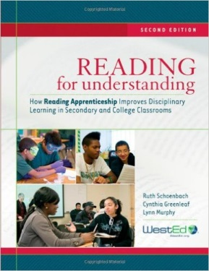
Reading for Understanding, 2nd Edition by Ruth Schoenbach, Cynthia Greenleaf, Lynn Murphy Amazon for about $19.00.
250 Ways to Awesomize your Teaching By Liz Falconer and Michele Lesmeister
A resource for teachers that includes tips for using internet tools and social media, and basic steps for incorporating Universal Design for Learning and Reading Apprenticeship design into virtual and face-to-face classroom environments. Available at https://www.lulu.com/shop/search.ep?keyWords=250+ways+to+awesomize+your+teaching&categoryId=107110 for $5.00

My Contact Information: Mlesmeister@RTC.edu

