The Reading Apprenticeship Framework

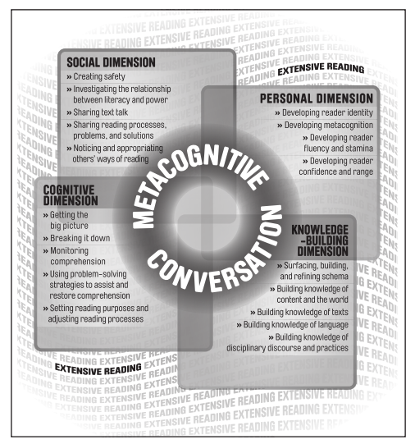

Engagement and the Social Dimension:
Setting Class Norms

YOU are the student!
  - What makes you comfortable in a classroom?

  - What are some things the teacher can do to support your learning?

  - What are some things classmates can do to support one another’s learning?

  - What would get in the way of your learning?

Engagement and the Personal Dimension:
Personal Reading Histories

Think-Pair-Share:

- What reading experiences stand out for you? High points? Low points?

- What has supported your development as a reader? What has discouraged it?

Representation, Action and Expression and the Cognitive Dimension:
Social Studies for the GED

The 13th Amendment | Rephrased
Neither slavery nor involuntary servitude,
except as a punishment for crime whereof the party shall have been duly convicted,
shall exist within the United States, or any place subject to their jurisdiction.

- What is the main idea in the 13th Amendment to the U.S. Constitution?

The 14th Amendment | Rephrased
All persons born or naturalized in the United States, and subject to the jurisdiction thereof, are citizens of the United States and of the state wherein they reside.
No state shall make or enforce any law which shall abridge the privileges or immunities of citizens of the United States;
nor shall any state deprive any person of life, liberty, or property, without due process of law;
nor deny to any person within its jurisdiction the equal protection of the laws.

- What is the main idea in the 14th Amendment to the U.S. Constitution?

The 15th Amendment | Rephrased
The right of citizens of the United States to vote shall not be denied or abridged
by the United States or by any state on account of race, color, or previous condition of servitude.

- What is the main idea in the 15th Amendment to the U.S. Constitution?

Representation, Action and Expression and the Cognitive and Knowledge-Building Dimensions:
Language Arts for the GED

- What is the author’s position in Passage A?
___________________________________________________________

___________________________________________________________

___________________________________________________________

- Analyzing Evidence: How does the author support her or his position?
Author’s Main Reasons and Evidence:

- Do you agree with the author’s position?

- Use at least one complete sentence to explain why agree or disagree with the author’s position:
____________________________________________________________

____________________________________________________________

____________________________________________________________

____________________________________________________________

- What is the author’s position in Passage B?
___________________________________________________________

___________________________________________________________

___________________________________________________________

- Analyzing Evidence: How does the author support her or his position?
Author’s Main Reasons and Evidence:

- Do you agree with the author’s position?

- Use at least one complete sentence to explain why agree or disagree with the author’s position:
____________________________________________________________

____________________________________________________________

____________________________________________________________

____________________________________________________________

Representation, Action and Expression and the Cognitive and Knowledge-Building Dimensions:
Math for the GED Science Test

Directions: Use this page to make notes on the procedures for solving Mean, Median, Mode and Range problems.

Notes
Mean
Median
Mode
Range
A Side-by-Side Look:
UDL Principles and Reading Apprenticeship Strategies
UDL Principle | Reading Apprenticeship Strategies
Multiple Means of Representation:  - Provide Options for Perception  - Highlight Patterns, Critical Features, Big Ideas and Relationships  - Activate or Supply Background Knowledge  - Clarify Vocabulary and Symbols  - Clarify Syntax and Structure  - Support Decoding of Text and Mathematical Notation | Cognitive Dimension:  - Model the Use of Graphic Organizers, Outlines, Response Logs and Notes  - Skim and Scan Texts  - Chunk Texts into Small Segments  - Review the Big Picture to Check for Comprehension  Knowledge Building Dimension:  - Brainstorm and Share Ideas, Knowledge and Information about a Topic  - Highlight Critical Text Features and Vocabulary  - Relate Visual and Text Information to Increase Comprehension  - Identify Roots, Prefixes and Suffixes to Make Meaning of Unfamiliar Vocabulary

UDL Principle | Reading Apprenticeship Strategies
Multiple Means of Action and Expression:  - Vary Methods for Response and Navigation  - Build Fluencies with Graduated Levels of Support (Scaffold)  - Support Planning and Strategy Development  - Enhance Capacity for Monitoring Progress | Cognitive Dimension:  - Test Understanding by Paraphrasing or Summarizing  - Visualize What is Described in the Text  - Represent Text Concepts and Content in Graphic Form and Through Metaphors and Analogies  - Organize and Keep Track of Ideas Through Graphic Organizers, Outlines, Response Logs and Notes.  - Read a Wide Range of Unfamiliar Texts and Celebrate Increases and Reader Fluency and Stamina  - Draw Attention to What Students Do Know When Reading Unfamiliar Texts

UDL Principle | Reading Apprenticeship Strategies
Multiple Means of Engagement:  - Minimize Threats and Distractions  - Foster Collaboration and Community  - Facilitate Coping Skills and Strategies  - Develop Self-Assessment and Reflection  - Optimize Relevance and Value | Social Dimension:  - Create Safety for Sharing Ideas  - Share Teachers’ and Classmates’ Reponses to Ideas Events and Language of Texts  - Talk About Confusing Aspects of Texts  - Share Strategies for Addressing Reading Challenges  - Try the Reading Strategies of Others  Personal Dimension:  - Write and Talk about Reading Experiences, Reading Habits and Reasons for Reading  Cognitive Dimension:  - Identify Purposes for Reading

Partner’s Activity:
UDL Principles and Reading Apprenticeship Strategies

- Use this form to make some notes about how your activity, or set of activities, addresses at least one UDL Principle and one Reading Apprenticeship domain.

UDL Principle | Reading Apprenticeship Domain

